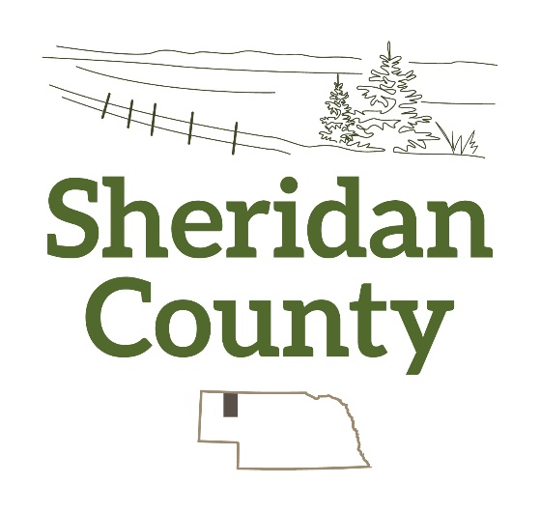
Sheridan County Tourism Board
2024
Tourism Grant Guidelines
And Application
Grant Opening Date: May 1, 2024
Deadline: May 31, 2024 or until 5 applications are received
Applications must be filled out completely and on time. It is recommended, but not required, that the applicants be present at the Sheridan County Tourism Board meeting at which their application is reviewed. Each applicant will be notified of when their application will be reviewed, if they would like to give a presentation to the Tourism Board. An organization can only apply for a grant once a year.
The role of the Sheridan County Tourism Board is to serve as a catalyst for tourism development and promotion. We will be a proactive leader among community organizations and help create collaborative solutions to identify and market the best of Sheridan County to visitors.
Grants shall be available for any visitor attraction in the county owned by the public or any nonprofit organization, the primary purpose of which is to operate the visitor attraction. Grants shall not be available for any visitor attraction where parimutuel wagering is conducted. This guideline is in accordance with Nebraska Legislative Statute 31-3720.
The type of grant available from Sheridan County Tourism is for Community Events or Tourism Attraction Improvement. Sheridan County Tourism will offer 5 grants per year. The value of each grant will be up to $800. The grant recipient will be responsible for a 20 percent cash match (example-total project costs $1000, Sheridan County will pay grant recipient $800 and the grant recipient will pay $200). These grants will be reimbursement grants meaning that grant recipients must submit invoices and proof of payment to be reimbursed for the approved grant. Upon submission and approval of these forms and final report, reimbursement will be made.
Crediting should be included on all printed material or advertising media with the words “sponsored in part by Sheridan County Tourism”. The Sheridan County Logo is available by emailing the Sheridan County Tourism Board at give4sc@gmail.com
Applicants will be notified in writing within 10 days after the review of the application with the Sheridan County Tourism Board’s decision.
The grant recipient will be responsible for submitting a final report 45 days after the grant project is completed to Sheridan County Tourism, PO Box 429, Rushville, NE 69360. The report must include a description of the project along with the answers to the following: Were the objectives to the project met? If not, what were the circumstances that led to the deficiency? Pictures of the project and copies of publications giving sponsorship credit to Sheridan County Tourism should also be attached to the final report. Final reports must include paid invoices. Project must be completed by December 31, 2024.
If you have any questions about the guidelines or application, please email give4sc@gmail.com. Thanks!

Grant Application
Today’s Date:__________________
Name of Organization_____________________________________________
Contact Person___________________________________________________
Address_________________________________________________________
Phone Number___________________________________________________
Email___________________________________________________________
Total Grant Funds Requested________________________________________
Please provide a brief description of the project:

Please attach a narrative to this application explaining how your project will benefit Sheridan County and increase tourism to this area.

Checklist:
Completed Application
Narrative
Completed Budget Sheet
Return these forms to:
Sheridan County Tourism, PO Box 429, Rushville, NE 69360

Budget Sheet
Organization______________________________________________________
Project Title______________________________________________________

Project Expense Description | Provided by Grant | Provided by Alternate Source
 | $ | $
Total Expense

